Function Points of Evendo

In this document we will explain our function point calculation.

What are Function Points?
Function Points are a „unit of measure” to express the amount of business functionality a software provides to a user. They are used to compute a functional size measurement of software.
The calculation is very difficult, but a function point calculator can help doing it.
A Function Point consists of various grading criteria you have to set yourself before you can calculate the Function Points of your Use-Cases. You have to determine the weighting factor for different points to calculate the complexity factor which scales the function points.

Our Function Point calculation
For our calculation we used a tool of the University of Michigan.
You can see an example of our calculation on our blog.
This are the resulting Graphs of our calculation:
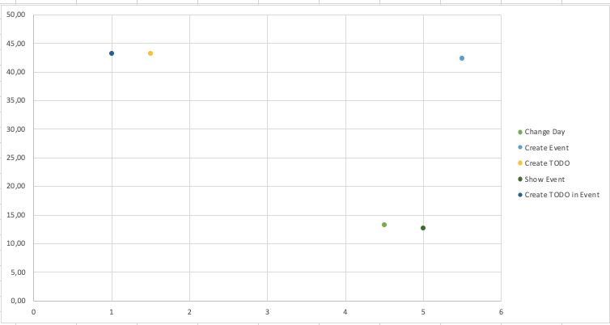Time VS Function Points
